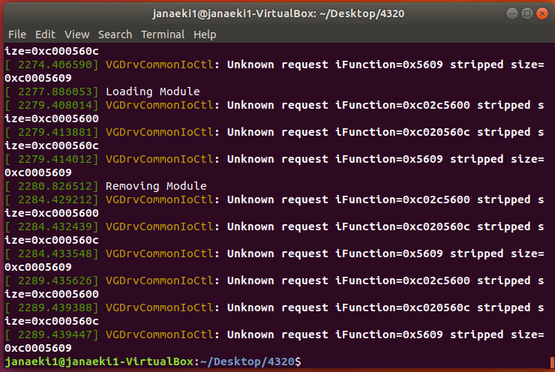

First, I made sure to have the “simple.c” source file and makefile in a separate directory. I used the code in the makefile to compile the “simple.c” file and create a kernel module. After the kernel module and additional files were created, the module was loaded using “sudo insmod simple.ko” in the terminal. Then, I immediately removed the module using “sudo rmmod simple” in the terminal. The “.ko” suffix is unnecessary when removing a module. Then, I checked the contents of the messages in the kernel log buffer using “dmesg” in the terminal.